Guidelines

Mandatory notifications about health students
Draft 2019

Contents

Executive summary 3
1 Mandatory notification requirements 4
1.1 What do these guidelines cover? 4
1.2 Who should make a mandatory notification? 4
1.3 How do I make a notification? 5
1.4 How does the National Law protect me? 5
1.5 What doesn’t need to be reported? 5
2 Guideline for reporting concerns about students 7
2.1 What issues must be reported? 7
2.2 What is ‘reasonable belief’? 7
2.3 What are my obligations? 8
Appendix A: National Law extracts 10

Executive summary
1 Mandatory notification requirements
To protect the public from the risk of harm, registered health practitioners and education providers must report concerns about health students. This is a legal requirement under the Health Practitioner Regulation National Law, as in force in each state and territory (the National Law). This section sets out:
- who must make a mandatory notification
- how to do it, and
- how you are legally protected when doing so.
It also explains what circumstances do not trigger a mandatory notification. In these cases, practitioners, education providers or members of the public can choose to make a voluntary notification.
2 Guideline for reporting concerns about students
Practitioners and education providers only need to notify us when they have a ‘reasonable belief’ that a student has an impairment that while undertaking clinical training may place the public at substantial risk of harm (a very high threshold for reporting risk of harm to the public). This section explains what reasonable belief is and what impairment means in this context.
The requirement to report is also based on the level of risk. This section also gives more advice about when impairment must be reported, and what your obligations are.

Mandatory notification requirements
These guidelines explain the requirements for making a mandatory notification about a student under the National Law. This protects the public by ensuring that risks posed by students undertaking clinical training are reported.
Read this section to understand the reporting requirements, who has to notify us and how to do this.

What do these guidelines cover?
Under the National Law, certain groups must make mandatory notifications about students under some limited circumstances, when their conduct poses a risk to the public.
The notifications must be made to the Australian Health Practitioner Regulation Agency (AHPRA) and the relevant National Board. Our key role is to protect the public by regulating the health professions. Together, we implement the National Registration and Accreditation Scheme (the National Scheme). The National Boards also manage notifications, register practitioners and most students, and set standards and policies for them. The exception for student registration is in psychology, where students are registered as provisional psychologists.
AHPRA cannot provide advice on specific circumstances. But we can provide information to help you decide whether to make a mandatory notification. Along with the National Boards, we developed these guidelines under section 39 of the National Law (see Appendix A). You can also find more information by:
- visiting our website, see: www.ahpra.gov.au/notifications, or
- calling us on 1300 419 495.
If AHPRA or a National Board receives a mandatory notification, the Board will consider all relevant information before deciding if action is needed to protect the public. It will not automatically take regulatory action.
These guidelines do not affect other legally mandatory notification requirements – for example, about child abuse or aged care issues. Nor do they cover when treating practitioners, non-treating practitioners or employers of practitioners must report practitioners. For more details please read our [insert hyperlink] AHPRA Guideline: Mandatory notifications about registered health practitioners.
These guidelines do not cover section 130 of the National Law, where a registered health practitioner or student must notify AHPRA of certain events themselves (also known as a self-notification). Information on notice of certain events is available on the AHPRA website.

Who should make a mandatory notification?
These groups may need to make a mandatory notification about students:
- treating practitioners (a practitioner who is providing treatment to a student)
- non-treating practitioners, and
- education providers.
Treating practitioners with a principal place of practice (PPP) in Western Australia are exempt from this requirement but may still have to make a mandatory notification as a non-treating practitioner (see section 1.5).
All three groups must report students who, by undertaking a clinical placement with an impairment, are placing the public at substantial or very high risk of harm.
Employers and other people do not have to make a mandatory notification about students, but they can raise concerns through a voluntary notification.

How do I make a notification?
You can make a mandatory notification to AHPRA on our website, see: www.ahpra.gov.au/notifications, or by calling us on 1300 419 495.
Our website also has information about how we manage both mandatory and voluntary notifications and explains how to raise a concern if you are in Queensland or New South Wales.
If you are making a mandatory notification and want your identity to be confidential, AHPRA will not reveal your identity to the student you are reporting.
If, after reading this guideline, you are still unsure about whether to make a mandatory notification, seek advice from your insurer or legal advisor.

How does the National Law protect me?
The National Law protects all registered health practitioners , employers and education providers who make notifications in good faith. ‘Good faith’ has its ordinary meaning of being well intentioned or without malice.
Section 237 provides protection from civil, criminal and administrative liability, including defamation, for people making notifications in good faith. However, if you make a notification that is frivolous, vexatious or not in good faith, you may be subject to regulatory action.
The National Law clarifies that making a notification is not a breach of professional etiquette or ethics, or a departure from accepted standards of professional conduct. It is consistent with professional conduct and a practitioner’s ethical responsibilities.
Privacy obligations do not prevent you from making a mandatory or voluntary notification.

What doesn’t need to be reported?
Treating and non-treating practitioners do not have to make mandatory notifications if they:
- are involved in legal proceedings, are providing legal advice or are a member of a quality assurance body with legal confidentiality requirements, and
- reasonably believe that someone else has already made a notification.
Treating practitioners with a principal place of practice (PPP) in Western Australia do not have to make a mandatory notification.. But these practitioners still have a professional and ethical obligation to protect and promote public health and safety, so they might either make a voluntary notification or encourage the student they are treating to self-report.
Please refer to Appendix A: National Law extracts to see if these exemptions apply to you.
You might not need to make a mandatory notification if a practitioner or education provider has made a report, and safeguards to reduce the risk to the public are being put in place.
Similarly, an education provider may have its own process for mandatory reporting obligations. To assess whether the process or circumstances reduce the risk of harm to the public, an employee who is a practitioner should talk to their employer about the concern. The employee practitioner might still have to make a mandatory notification.
However, the National Law also allows people to make voluntary notifications. Anyone (including practitioners and education providers) can make a voluntary notification about a student if they believe the student’s impairment could have a detrimental effect on their clinical placement.
For more information about making a voluntary notification, please go to our website, see: www.ahpra.gov.au/notifications, or call us on 1300 419 495.

Guideline for reporting concerns about students
This section defines impairment, the only issue that may trigger a mandatory notification about a student, and the concept of ‘reasonable belief’. It explains your obligations, when you must make a mandatory notification about a student and when you do not need to report.
Read this section to help assess whether you need to make a mandatory notification.

What issues must be reported?
A mandatory notification about a student can only be triggered by concerns about impairment. The National Law defines ‘impairment’ as ‘a physical or mental impairment, disability, condition or disorder (including substance abuse or dependence) that detrimentally affects or is likely to detrimentally affect the student’s capacity to carry out clinical training:
- as part of the approved program of study in which the student is enrolled, or
- arranged by an education provider.’
A health condition and impairment are not the same thing. An illness or condition that does not have a detrimental impact on a student’s capacity to practise is not an impairment.
You must assess if there is a substantial risk of harm to the public when deciding whether to make a notification. In this context, ‘the public’ means:
- the student’s patients or clients in a clinical training environment, and
- the wider community that could be put at risk of harm.
Concerns about intoxication, standards of practice or sexual misconduct cannot trigger a mandatory notification about a student. Although they are not grounds for a mandatory notification under the National Law, an education provider or health service provider may deal with such concerns under their own policies and processes.

What is ‘reasonable belief’?
Before making a mandatory notification, you must form a ‘reasonable belief’. To do so, you generally need direct knowledge (not just a suspicion) of the behaviour that led to the concern. As a practitioner or education provider, you are most likely to do this when you directly observe the conduct. Speculation, rumours, gossip or innuendo are not enough to form a reasonable belief.
You may have a report from a reliable source or sources about conduct they directly experienced or observed. In that case, you should encourage the person with the most direct knowledge of the conduct to consider whether to make a mandatory notification themselves.
Your professional background, level of insight, experience and expertise will help you form a reasonable belief. Your mandatory notification should be based on personal knowledge of reasonably trustworthy facts or circumstances that would justify a person of reasonable caution, acting in good faith, to believe that the concern and a risk to the public exists.
These principles about forming a ‘reasonable belief’ come from legal cases. In short, a reasonable belief is a state of mind based on reasonable grounds. It is formed when all known considerations, including matters of opinion, are objectively assessed and taken into account.

What are my obligations?
You must make a notification if you form the reasonable belief that a student, undertaking clinical training with an impairment, is placing the public at substantial risk of harm (a very high threshold for reporting risk of harm to the public).
A student may carry out clinical training with a mental health condition, physical health condition or physical illness, but that is not enough to trigger a mandatory notification.
Similarly, if the student’s impairment affects their capacity to carry out clinical training but does not place the public at substantial risk of harm, you do not need to make a mandatory notification.
You should only make a notification if you believe there is a substantial risk of harm. A substantial risk of harm is a very high threshold for reporting risk of harm to the public.
Example 1: You have been made aware that one of your students has been diagnosed with a mental health condition, which at times has required hospitalisation. The condition is now responding well to treatment, and the student is compliant with the treatment plan. The student is due to go on clinical placement next month, however, having considered the risk factors, as there is not a very high risk of harm to the public, you decide a mandatory notification is not required.
Consider if the risk to the public is controlled or managed through effective treatment or other strategies. If so, this decreases the risk of harm – and, if the likelihood is rare or possible, you do not need to report.
Controls that reduce the risk and severity of harm to the public affect the obligation to report. So you do not need to report if there are effective safeguards to manage the impairment, such as:
- treatment
- a break from study, such as sick leave
- modified scope of practice
- compliance with monitoring and supervision, or
- a reasonable belief that AHPRA has already been notified.

Use the following chart to help assess the level of risk. Factors including circumstance, practice context, controls such as oversight and reporting, and other arrangements can affect the level of risk and the need to report. The risk assessment for a very high risk of harm should holistically consider all relevant factors, with some factors weighted more heavily than others, depending on the circumstance.

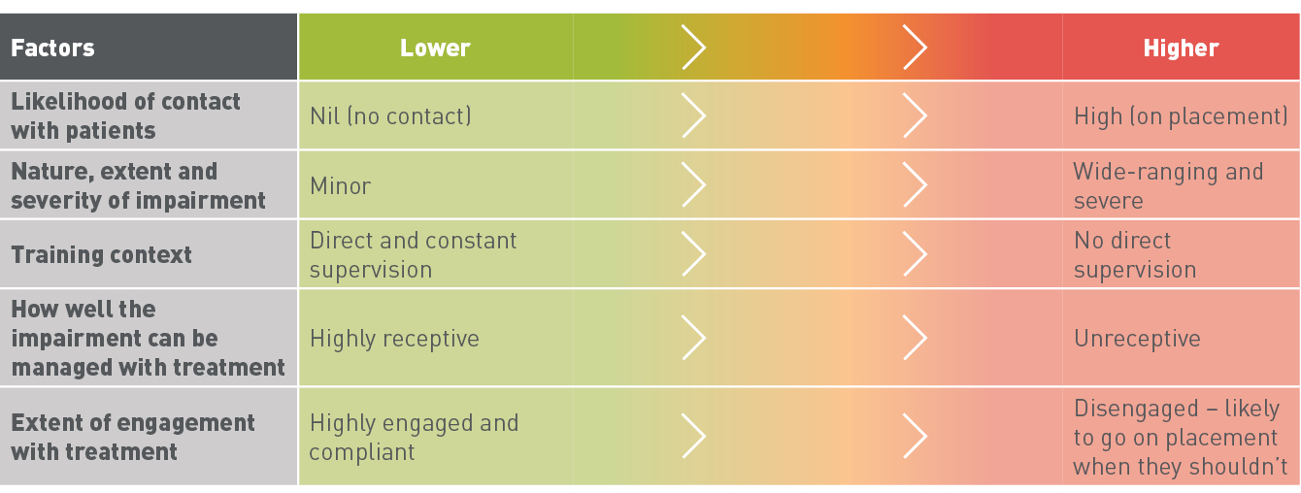
Factors to help you assess the risk of harm

There are consequences for practitioners and education providers who fail to make a mandatory notification when they have to, although this is not a criminal offence under the National Law:
- If you are a practitioner who has failed to notify, your National Board may take regulatory action against you (such as, for example, a caution). It will consider all the circumstances before it decides whether to do so.
- If you are an education provider who has failed to notify (as section 143 of the National Law requires), the National Board that registered the student must publish details of this on its website. If the Board recommends it, AHPRA may make a statement about the failure in our annual report.
Mandatory notification obligations only extend to an education provider’s (organisation’s) staff if the staff member is also a registered practitioner. An education provider is expected to have processes and protocols in place to assess when and how it would make a mandatory notification.
Use the following flowchart to help you assess whether to make a mandatory notification.
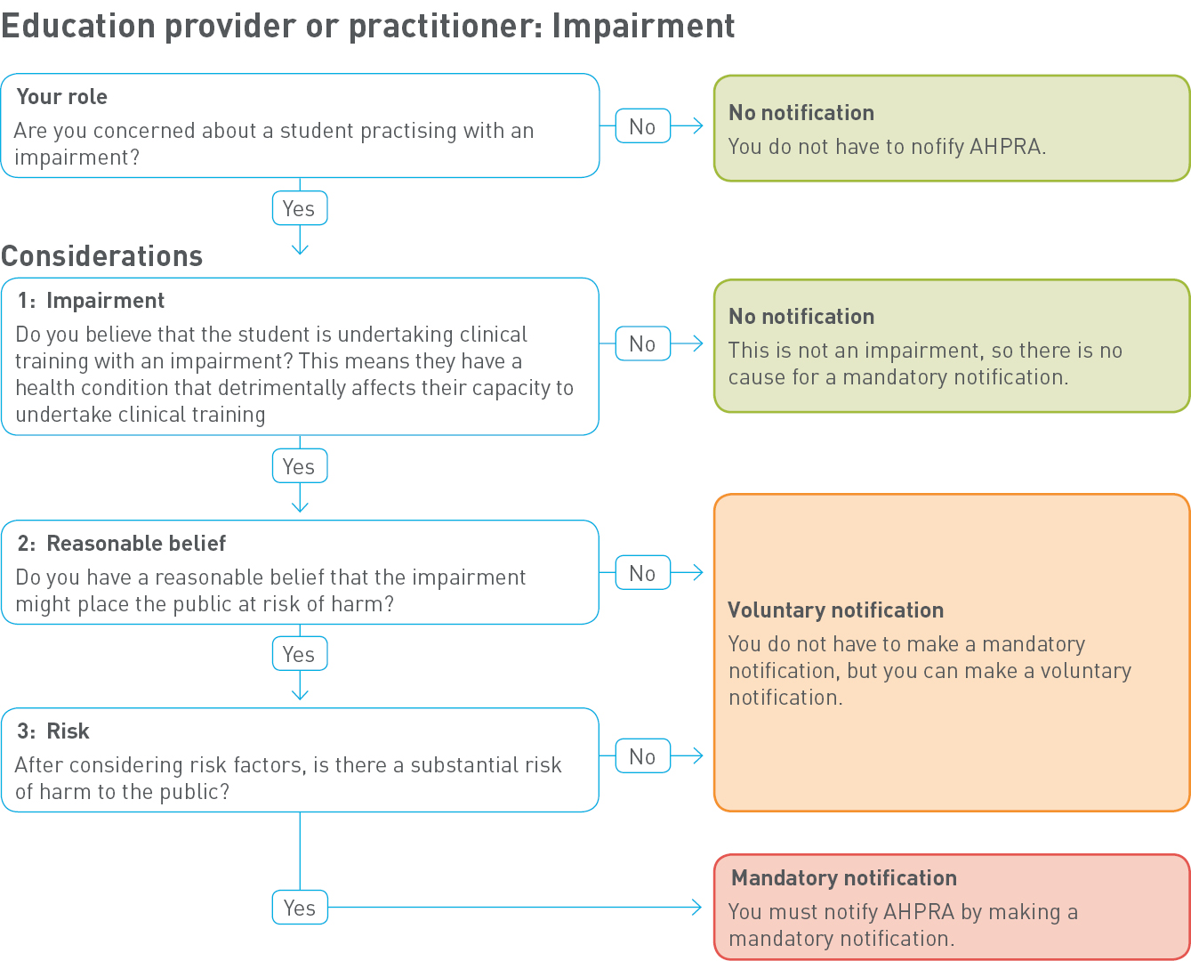

Appendix A: National Law extracts
5 Definitions
Impairment, in relation to a person, means the person has a physical or mental impairment, disability, condition or disorder (including substance abuse or dependence) that detrimentally affects or is likely to detrimentally affect—
(a) for a registered health practitioner or an applicant for registration in a health profession, the person’s capacity to practise the profession; or
(b) for a student, the student’s capacity to undertake clinical training—
(i) as part of the approved program of study in which the student is enrolled; or
(ii) arranged by an education provider.
Education provider means—
(a) a university; or
(b) a tertiary education institution, or another institution or organisation, that provides vocational training; or
(c) a specialist medical college or other health profession college.
Part 5 National Boards
Division 3 Registration standards and codes and guidelines
41 Use of registration standards, codes or guidelines in disciplinary proceedings
An approved registration standard for a health profession, or a code or guideline approved by a National Board, is admissible in proceedings under this Law or a law of a co-regulatory jurisdiction against a health practitioner registered by the Board as evidence of what constitutes appropriate professional conduct or practice for the health profession.
Part 8 Health, performance and conduct
Division 2 Mandatory notifications
140 Definition of notifiable conduct
In this Division—
notifiable conduct, in relation to a registered health practitioner, means the practitioner has—
(a) practised the practitioner’s profession while intoxicated by alcohol or drugs; or
(b) engaged in sexual misconduct in connection with the practice of the practitioner’s profession; or
(c) placed the public at risk of substantial harm in the practitioner’s practice of the profession because the practitioner has an impairment; or
(d) placed the public at risk of harm by practising the profession in a way that constitutes a significant departure from accepted professional standards.
141 Mandatory notifications by health practitioners other than treating practitioners
(1) This section applies to a registered health practitioner (the first health practitioner) who, in the course of practising the first health practitioner’s profession, forms a reasonable belief that—
(a) another registered health practitioner (the second health practitioner) has behaved in a way that constitutes notifiable conduct; or
(b) a student has an impairment that, in the course of the student undertaking clinical training, may place the public at substantial risk of harm.
(2) The first health practitioner must, as soon as practicable after forming the reasonable belief, notify the National Agency of the second health practitioner’s notifiable conduct or the student’s impairment.
[Note: See section 237 which provides protection from civil, criminal and administrative liability for persons who, in good faith, make a notification under this Law. Section 237(3) provides that the making of a notification does not constitute a breach of professional etiquette or ethics or a departure from accepted standards of professional conduct and nor is any liability for defamation incurred.]
(2A) However, subsection (2) does not apply if the first health practitioner forms the reasonable belief in the course of providing a health service to the second health practitioner or student.
(3) A contravention of subsection (2) by a registered health practitioner does not constitute an offence but may constitute behaviour for which action may be taken under this Part.
(4) For the purposes of subsection (1), the first health practitioner does not form the reasonable belief in the course of practising the profession if—
(a) the first health practitioner—
(i) is employed or otherwise engaged by an insurer that provides professional indemnity insurance that relates to the second health practitioner or student; and
(ii) forms the reasonable belief the second health practitioner has behaved in a way that constitutes notifiable conduct, or the student has an impairment, as a result of a disclosure made by a person to the first health practitioner in the course of a legal proceeding or the provision of legal advice arising from the insurance policy; or
(b) the first health practitioner forms the reasonable belief in the course of providing advice in relation to the notifiable conduct or impairment for the purposes of a legal proceeding or the preparation of legal advice; or
(c) the first health practitioner is a legal practitioner and forms the reasonable belief in the course of providing legal services to the second health practitioner or student in relation to a legal proceeding or the preparation of legal advice in which the notifiable conduct or impairment is an issue; or
(d) the first health practitioner—
(i) forms the reasonable belief in the course of exercising functions as a member of a quality assurance committee, council or other body approved or authorised under an Act of a participating jurisdiction; and
(ii) is unable to disclose the information that forms the basis of the reasonable belief because a provision of that Act prohibits the disclosure of the information; or
(e) the first health practitioner knows, or reasonably believes, the National Agency has been notified of the notifiable conduct or impairment that forms the basis of the reasonable belief.
141A Mandatory notifications by treating practitioners of sexual misconduct
(1) This section applies to a registered health practitioner (the treating practitioner) who, in the course of providing a health service to another registered health practitioner (the second health practitioner), forms a reasonable belief that the second health practitioner has engaged, is engaging, or is at risk of engaging, in sexual misconduct in connection with the practice of the practitioner’s profession.
(2) The treating practitioner must, as soon as practicable after forming the reasonable belief, notify the National Agency of the second health practitioner’s conduct that forms the basis of the reasonable belief.
[Note: See section 237 which provides protection from civil, criminal and administrative liability for persons who, in good faith, make a notification under this Law.]
(3) A contravention of subsection (2) by the treating practitioner does not constitute an offence but may constitute behaviour for which action may be taken under this Part.
(4) This section applies subject to section 141C.
141B Mandatory notifications by treating practitioners of substantial risk of harm to public
(1) Subsection (2) applies to a registered health practitioner (the treating practitioner) who, in the course of providing a health service to another registered health practitioner (the second health practitioner), forms a reasonable belief that the second health practitioner is placing the public at substantial risk of harm by practising the profession—
(a) while the practitioner has an impairment; or
(b) while intoxicated by alcohol or drugs; or
(c) in a way that constitutes a significant departure from accepted professional standards.
(2) The treating practitioner must, as soon as practicable after forming the reasonable belief, notify the National Agency of the second health practitioner’s conduct that forms the basis of the reasonable belief.
[Note: See section 237 which provides protection from civil, criminal and administrative liability for persons who, in good faith, make a notification under this Law.]
(3) Subsection (4) applies to a registered health practitioner (also the treating practitioner) who, in the course of providing a health service to a student, forms a reasonable belief that the student has an impairment that, in the course of the student undertaking clinical training, may place the public at substantial risk of harm.
(4) The treating practitioner must, as soon as practicable after forming the reasonable belief, notify the National Agency of the student’s impairment.
[Note: See section 237 which provides protection from civil, criminal and administrative liability for persons who, in good faith, make a notification under this Law.]
(5) In considering whether the public is being, or may be, placed at substantial risk of harm, the treating practitioner may consider the following matters relating to an impairment of the second health practitioner or student—
(a) the nature, extent and severity of the impairment;
(b) the extent to which the second health practitioner or student is taking, or is willing to take, steps to manage the impairment;
(c) the extent to which the impairment can be managed with appropriate treatment;
(d) any other matter the treating practitioner considers is relevant to the risk of harm the impairment poses to the public.
(6) A contravention of subsection (2) or (4) by the treating practitioner does not constitute an offence but may constitute behaviour for which action may be taken under this Part.
(7) This section applies subject to section 141C.
141C When practitioner does not form reasonable belief in the course of providing health service
(1) This section applies if a registered health practitioner (the first health practitioner) forms a reasonable belief about—
(a) a matter, relating to another registered health practitioner (the second health practitioner), mentioned in section 141A(1) or 141B(1); or
(b) a matter, relating to a student, mentioned in section 141B(3).
(2) For this Division, the first health practitioner is taken not to form the reasonable belief in the course of providing a health service to the second health practitioner or student if—
(a) the first health practitioner—
(i) is employed or otherwise engaged by an insurer that provides professional indemnity insurance that relates to the second health practitioner or student; and
(ii) forms the reasonable belief about the matter as a result of a disclosure made by a person to the first health practitioner in the course of a legal proceeding or the provision of legal advice arising from the insurance policy; or
(b) the first health practitioner forms the reasonable belief in the course of providing advice in relation to the matter for the purposes of a legal proceeding or the preparation of legal advice; or
(c) the first health practitioner is a legal practitioner and forms the reasonable belief in the course of providing legal services to the second health practitioner or student in relation to a legal proceeding or the preparation of legal advice in which the matter is an issue; or
(d) the first health practitioner—
(i) forms the reasonable belief in the course of exercising functions as a member of a quality assurance committee, council or other body approved or authorised under an Act of a participating jurisdiction; and
(ii) is unable to disclose the information that forms the basis of the reasonable belief because a provision of that Act prohibits the disclosure of the information; or
(e) the first health practitioner knows, or reasonably believes, the National Agency has been notified of the matter that forms the basis of the reasonable belief.
142 Mandatory notifications by employers
(1) If an employer of a registered health practitioner reasonably believes the health practitioner has behaved in a way that constitutes notifiable conduct, the employer must notify the National Agency of the notifiable conduct.
[Note: See section 237 which provides protection from civil, criminal and administrative liability for persons who, in good faith, make a notification under this Law. Section 237(3) provides that the making of a notification does not constitute a breach of professional etiquette or ethics or a departure from accepted standards of professional conduct and nor is any liability for defamation incurred.]
(2) If the National Agency becomes aware that an employer of a registered health practitioner has failed to notify the Agency of notifiable conduct as required by subsection (1), the Agency must give a written report about the failure to the responsible Minister for the participating jurisdiction in which the notifiable conduct occurred.
(3) As soon as practicable after receiving a report under subsection (2), the responsible Minister must report the employer’s failure to notify the Agency of the notifiable conduct to a health complaints entity, the employer’s licensing authority or another appropriate entity in that participating jurisdiction.
(4) In this section—
employer, of a registered health practitioner, means an entity that employs the health practitioner under a contract of employment or a contract for services.
licensing authority, of an employer, means an entity that under a law of a participating jurisdiction is responsible for licensing, registering or authorising the employer to conduct the employer’s business.
143 Mandatory notifications by education providers
(1) An education provider must notify the National Agency if the provider reasonably believes—
(a) a student enrolled in a program of study provided by the provider has an impairment that, in the course of the student undertaking clinical training as part of the program of study, may place the public at substantial risk of harm; or
(b) a student for whom the education provider has arranged clinical training has an impairment that, in the course of the student undertaking the clinical training, may place the public at substantial risk of harm;
[Note: See section 237 which provides protection from civil, criminal and administrative liability for persons who make a notification under this Law. Section 237(3) provides that the making of a notification does not constitute a breach of professional etiquette or ethics or a departure from accepted standards of professional conduct and nor is any liability for defamation incurred.]
(2) A contravention of subsection (1) does not constitute an offence.
(3) However, if an education provider does not comply with subsection (1)-
(a) the National Board that registered the student must publish details of the failure on the Board's website; and
(b) the National Agency may, on the recommendation of the National Board, include a statement about the failure in the Agency's annual report.
144 Grounds for voluntary notification
(1) A voluntary notification about a registered health practitioner may be made to the National Agency on any of the following grounds—
(a) that the practitioner’s professional conduct is, or may be, of a lesser standard than that which might reasonably be expected of the practitioner by the public or the practitioner’s professional peers;
(b) that the knowledge, skill or judgment possessed, or care exercised by, the practitioner in the practice of the practitioner’s health profession is, or may be, below the standard reasonably expected;
(c) that the practitioner is not, or may not be, a suitable person to hold registration in the health profession, including, for example, that the practitioner is not a fit and proper person to be registered in the profession;
(d) that the practitioner has, or may have, an impairment;
(e) that the practitioner has, or may have, contravened this Law;
(f) that the practitioner has, or may have, contravened a condition of the practitioner’s registration or an undertaking given by the practitioner to a National Board;
(g) that the practitioner’s registration was, or may have been, improperly obtained because the practitioner or someone else gave the National Board information or a document that was false or misleading in a material particular.
(2) A voluntary notification about a student may be made to the National Agency on the grounds that—
(a) the student has been charged with an offence, or has been convicted or found guilty of an offence, that is punishable by 12 months imprisonment or more; or
(b) the student has, or may have, an impairment; or
(c) that the student has, or may have, contravened a condition of the student’s registration or an undertaking given by the student to a National Board.
145 Who may make voluntary notification
Any entity that believes that a ground on which a voluntary notification may be made exists in relation to a registered health practitioner or a student may notify the National Agency.
[Note: See section 237 which provides protection from civil, criminal and administrative liability for persons who, in good faith, make a notification under this Law.]
Division 4 Making a notification
146 How notification is made
(1) A notification may be made to the National Agency—
(a) verbally, including by telephone; or
(b) in writing, including by email or other electronic means.
(2) A notification must include particulars of the basis on which it is made.
(3) If a notification is made verbally, the National Agency must make a record of the notification.
Part 11 Miscellaneous
Division 1 Provisions relating to persons exercising functions under Law
237 Protection from liability for persons making notification or otherwise providing information
(1) This section applies to a person who, in good faith—
(a) makes a notification under this Law; or
(b) gives information in the course of an investigation or for another purpose under this Law to a person exercising functions under this Law.
(2) The person is not liable, civilly, criminally or under an administrative process, for giving the information.
(3) Without limiting subsection (2)—
(a) the making of the notification or giving of the information does not constitute a breach of professional etiquette or ethics or a departure from accepted standards of professional conduct; and
(b) no liability for defamation is incurred by the person because of the making of the notification or giving of the information.
(4) The protection given to the person by this section extends to—
(a) a person who, in good faith, provided the person with any information on the basis of which the notification was made or the information was given; and
(b) a person who, in good faith, was otherwise concerned in the making of the notification or giving of the information.

